**TITLE: PLANT INCUBATOR - SMART GROWTH ENVIRONMENT**

**\*Ansa Ahmed**

*\*Ansa Ahmed, Electronics and Telecommunications Department, SSGI, Bhilai, ansademha24@gmail.com*

**Abstract**

*This paper primarily describes a Plant Incubator that integrates an artificial growth environment monitored using Internet by laying out a smart network. The objective of this project is to monitor the humidity and temperature conditions of soil and the environment in order to promote a healthy growth of plants. Designing of the project is layed out using a microcontroller that hereby allows the user to connect with this growth environment via Internet. Some plants do not survive in the normal environment but that types of plant is important in field of medicine and research. Humidity and temperature maintenance are currently done at a small scale using very easily available components. This concept can be seen in large scale implementation in the field of geoponics, aeroponics and hydroponics. The methodology is to study the humidity and temperature conditions required by the plant and then feed it to the microcontroller which in turn monitors the environment to maintain the conditions for healthier growth.*

1. **INTRODUCTION**

Plant Incubator is designed to monitor conditions required by the plant to grow in. They are used to create artificial environment for the plant so that it can grow and nourish into a healthy one. They are sometimes called environmental chambers or terrestrial plant growth chambers.  
The present model of Plant Incubator relates to improvements in condition for germinating the seeds of plants of all kinds. Each chamber is tailored to a specific application, with growth space, lighting type and climactic conditions. These plant growth chambers provide precision environmental conditions for the growth of vibrant, healthy plants. Our chambers deliver the most accurately controlled conditions for optimum plant research and repeatable, reliable results.

1. **OBJECTIVE**

Plant growth chamber is a device that monitors and controls the physical parameters like temperature, humidity and moisture.

1. **DESIGN**

From a remedial point of view, the plant incubator is a useful device that helps in growing certain specific plants that cannot be grown and planted easily at home by an untrained individual. All it requires is the optimal temperature and conditions needed for that specific plant to grow in. Some Specific plants are unable to survive in normal environment as absence of favourable temperature for its solution we have created the incubator with Temperature sensor. It gives advantage of set the temperature according to plant requirement. As Soil and humidity play very important role in the growth in the plant. That why another equipment Soil moisture sensor has used. If favourable condition (set according to the plant requirement) is disturbed or not fulfilled then  
Buzzer indicates the user. To fulfil the water requirement water pump has added in the incubator which supply water time to time. When inside temperature of the incubator has decreased means become lower than the set temperature for the growth of the plant a 60 watt bulb has used to maintain temperature of inside the incubator. Here Octabrix is used as microcontroller from which all the element are connected.

* 1. **COMPONENT DETAILS**
     1. **Microcontroller**

The Microcontroller board we used here is called Octabrix. Octabrix is a Wi-Fi development board based on the famous and easily available Wi-Fi SoC ESP8266. ESP8266 is a wireless SoC that provides ability to embed Wi-Fi capabilities.

* + 1. **Soil Moisture Sensor**  
       This sensor measures the volumetric content of water inside the soil and gives us the moisture  
       level as output.
    2. **Temperature and Humidity Sensor**

DHT11 Temperature and Humidity Sensor features a calibrated digital signal output with the temperature and humidity sensor capability.

* + 1. **60-Watt Bulb**

The bulb is used to provide heat due to power losses and the heat generated by it is adequate enough to maintain the temperature of the environmental set-up.

* + 1. **Buzzer**

The buzzer or beeper is an audio signaling device, which may be mechanical, electromechanical, or piezoelectric.

* + 1. **Cooling Fan**

An electric cooling fan is used in a wide variety of applications, from electrical enclosure cooling fans to industrial cooling fans.

* + 1. **Other components**
* Relay module for switching components.
* Water pump for watering plants.
* Humidifier according to usage.

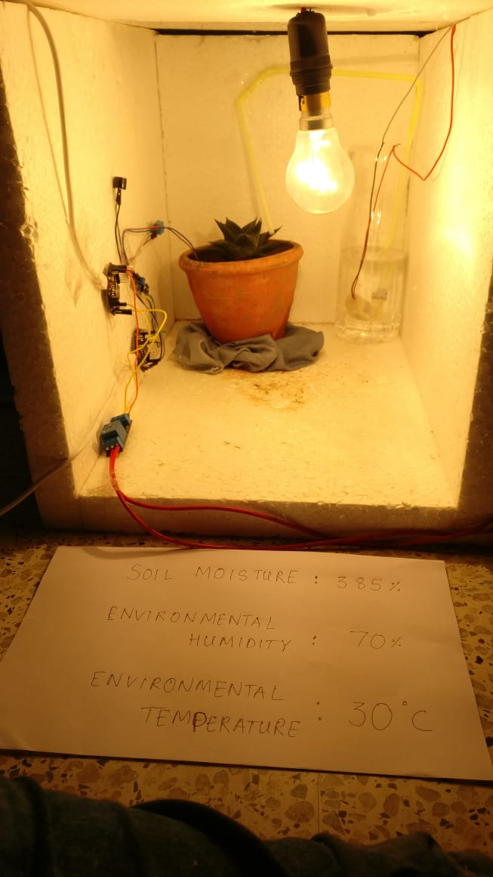

1. **CONCLUSION**

Thus as demonstrated and from all the observations, it can be noted that a plant incubator can be built. In this incubator the

optimal temperature and humidity conditions can be generated so that the plant can healthily grow. It serves an important role

in the field of medicine and research. Medicinal as well as expensive plants which have very critical environmental needs can also be grown in this incubator.

**ACKNOWLEDGEMENT**

I express my sincere gratitude the CCET family and the coordinators of TECHNOLOGIA 2019 for giving me an opportunity to present my research work. I would also like to thank all faculty members, friends and family who have been part of this endeavour and whoever lent me a helping hand in times of trouble.

**REFERENCES**

1. Effects of blue, red, and blue/red lights of two different ppf levels on growth and morphogenesis of lettuce plants T. Yanagi, K. Okamoto, S. Takita ISHS Acta Horticulturae 440: Internation al Symposium on Plant Production in Closed Ecosystems
2. Resource use efficiency of closed plant production system with artificial light: Concept, estimation and application to plant factory Rosenzweig, C. and Liverman, D. (1992) Predicted effects of climate change on agriculture: A comparison of temperate and tropical regions Global Climate Change: Implication, Challenges and Mitigation Measures, Philadelphia (ed. Majumdar, S.K.). Pennsylvania Academy of Sciences, pp. 342–361.
3. The effects of light-emitting diode lighting on greenhouse plant growth and quality Olle, M., & Viršile, A. (2013). Agricultural and Food Science, 22(2), 223-234. Published on Jun 6, 2013
4. Environmental control and operation monitoring in a plant factory using artificial light A. Ikeda, Y. Tanimura, K. Ezaki, Y. Kawai, S. Nakayama, K. Iwao, H. Kageyama ISHS Acta Horticulturae 304: I International Workshop on Sensors in Horticulture